Meeting 30
Course / Class #: CECS 4800

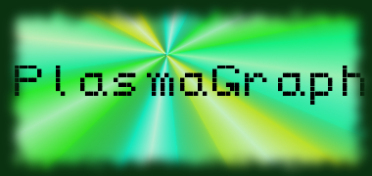
Date: 15 May 2014
Project Name: PlasmaGraph

Has been done:
- Tests with test data. (Headers don’t work due to nondeterministic order in which columns are extracted from the file.)
- SPMP work (Third and fourth revisions; added Gantt Chart schedule and budget to document.)
- SDD (Started work on diagrams [Use Case / Requirement sequence diagrams, Package / Class diagrams done, object state machine diagrams and program flow diagram next]; document structure created; Started work on textual explanations.)
- SRS finalized.
- STD work.

What will be done:
- Remaining documentation. (SPMP, STD, SDD)
- Finish presentations, and start gathering materials and designing for project poster.
- PlasmaGraph user test on Friday, May 16, 2014.
- Finish Javadoc.

Materials Used: 2x Computers, Internet connections, Microsoft Visio 2013 / Dia (Diagramming Tools), OpenOffice Writer / Microsoft Word 2013 (Document-writing Tools), Eclipse / NetBeans IDE (Programming Tools), Microsoft PowerPoint 2013 (Presentation Tool), Microsoft Project 2013 (Scheduling Tool).

Team Members: ________________________________
Gerardo A. Navas

________________________________
Daniel Quintini
Advisor:

________________________________
Prof. Luis A. Ortiz
Prof. Luis A. Ortiz

